Project Report
On
“MysqlPlus-GUI for Mysql”

Submitted By
Amit Anil Bhalerao

Master Of Computer Application (Semester V)
Vidya Pratishtan’s Institute Of Information Technology (VIIT) ,
Vidya Nagari, MIDC, Bhigwan Road, Baramati,
Dist Pune 413 133
(2009-2010)



Certificate
This is to certify that, Amit Anil Bhalerao of MCA Course SEM-V has completed his
Project Work Titled “MysqlPlus-GUI for Mysql”, as a part of curriculum, during the Academic Year 2009-2010.

Mrs. Sushma Patil Dr. Amol C Goje
Head of the Department Director

Name of Examiners Sign Examiners:

1.______________________ __________

2.______________________ __________

Date of Examination:

Guide Certificate
This is to certify that, Amit Anil Bhalerao of MCA Course, SEM-V has successfully completed his/her Mini Project Titled “MysqlPlus-GUI for Mysql”, under my guidance.

Signature of Guide

Mugdha Phadnis
(Project Guide)

Date :

ACKNOWLEDGEMENT

We would like to thank all people whose support and cooperation has been an invaluable asset during the course of this project.

We would like to thank our Internal Project Guide Prof. Mugdha Phadnis for guiding us throughout this project and giving it the shape. It would have been impossible to complete the project without her support, valuable suggestions, encouragement and guidance.

We convey our gratitude to Prof. Mugdha Phadnis for her motivation and providing various facilities throughout the year, which helped us greatly in the whole process of the project.

We are also grateful for other teaching and non-teaching staff members of the Computer Department for directly or indirectly helping us for the completion of this project and resources provided.

Amit Bhalerao

Index

Chapter Number | Topic | Page No.
Chapter Number | Topic | From | To
1  1.1  1.2  1.3 | Introduction  - Introduction  - Existing system & need of the system  - Limitations of Existing system | 1  1  2  4 | 4
2  2.1  2.2  2.3 | Proposed System  - Objectives of the Proposed System.  - Scope of the System  - Operational Environment | 5  5  6  7 | 7
3  3.1  3.2 | Requirement Determination and Analysis  - Requirement Determination Techniques  - Feasibility Study and Tools used for Analysis | 8  8  9 | 10
4  4.1  4.2  4.3  4.4  4.5 | System Analysis & Design  - Context Level DFD  - First Level DFD  - Use Case Diagram  - Sequence Diagram  - Class Diagram | 11  11  12  13  14  15 | 15
5 | Program Specification and Coding system | 16 | 17
6 | Screen Layouts | 18 | 51
7 | Proposed Enhancements | 52 | --
8  8.1  8.2  8.3 | Benefits of the system  - Tangible & Intangible benefits.  - Limitations of the system  - Conclusions & Recommendations | 53  53  54  55 | 55
9 | Bibliography  - References | 56

1

MysqlPlus-GUI for Mysql

1.1 INTRODUCTION
Now-a-days each and every system that requires storing the data for future use uses any well known Database System at the backend such as Oracle, Postgresql, Mysql, Sqllite, Mimer, and Sybase. All the databases mentioned are available for download to use them on any operating system.
The main goal of this system is to reduce the complexities while creating and maintaining the operations related to a database using a very user friendly Graphical User Interface (GUI).The system will have an ability to create new users, database, and tables dropping existing users, databases, tables. Other database related issues such as updation, insertion, deletion are also supported. The issues related to PL/SQL such as creation of views, indexes, functions, triggers, procedures are also supported.

Amit Anil Bhalerao 1
MysqlPlus-GUI for Mysql

  - Existing system and need of the system
Existing System:
MySQL is a popular Structured Query Language (SQL) database server.Like other SQL servers, MySQL provides the means of accessing and managing SQL databases. However, MySQL also provides tools for creating database structures, as well as for adding, modifying, and removing data from those structures. Because MySQL is a relational database, data can be stored and controlled in small, manageable tables.Those tables can be used in combination to create flexible yet complex data structures.
A Swedish company called MySQL AB is responsible for developing MySQL.Because MySQL is an open-source product it has been ported to several different operating systems.The initial Internet release of MySQL has been ported to a host of UNIX operating systems, Win32, Mac OS X.
MySQL is a relational Database Management System. It includes not only server process to manage databases, but also tools for accessing the databases and building applications against those databases.
Following are the tools that a MySQL server includes
- mysql - Used to execute SQL commands
- mysqlaccess - Manage users
- mysqladmin - Manage database server
- mysqld - MySQL server process
- mysqldump - Dumps the definition and contents of a MySQL database
- mysqlhotcopy - Performs a hot backup of a MySQL database
- mysqlimport - Imports data in different file formats into a MySQL table
- mysqlshow - Shows information about MySQL server and any objects
- safe_mysqld - Safely starts up and manages the mysqld process

Amit Anil Bhalerao 2

MysqlPlus-GUI for Mysql

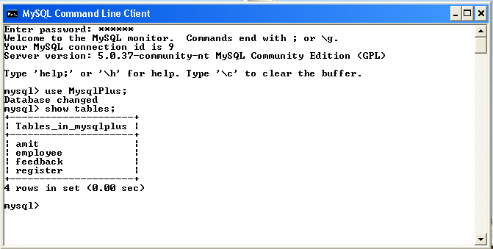
Fig 1 MySQL Command Line Prompt
Need of the System:
Command Line MySql provides following services
- Creating and dropping databases
- Listing the existing databases
- Creating and dropping tables
- Inserting,Deleting,Updating and Altering tables data
- Creating, Dropping and Altering Views and Indexes
- Creating,Dropping,Editing user accounts
- Granting and revoking privileges
- Creating and dropping functions,triggers,procedures

Amit Anil Bhalerao 3

MysqlPlus-GUI for Mysql

  - Limitations Of Existing System
The Limitations of Existing System are
- User needs to remember the Syntax of each Command.

- Problems while understanding the errors.

- Not a User Friendly Environment.

- Too technical explanation of Help.

- No proper explanation of errors.

- Help without examples.

Amit Anil Bhalerao 4

2

MysqlPlus-GUI for Mysql

  - Objectives of the Proposed System
Objectives of the Proposed System are
➔ Creating and dropping databases.
➔ Listing the existing databases.
➔ Creating and dropping tables.
➔ Inserting, Deleting, Updating and Altering tables data.
➔ Creating, Dropping and Altering Views and Indexes.
➔ Creating, Dropping, Editing user accounts.
➔ Granting and revoking privileges.
- Creating and dropping functions, triggers, procedures.
➔ Loading and Storing Query to and from a text file.
➔ Cut Copy, Paste, Undo, Redo text to and from System.
➔ Starting and Stopping MySql Service.
➔ Flushing Query Cache

Amit Anil Bhalerao 5

MysqlPlus-GUI for Mysql

  - Scope of the System
The usual way of handling the database for a MySql is by using command line. The main disadvantage of this type of System is remembering the commands and their syntax. This System provides user friendly Graphical User Interface (GUI) for handling those commands using Java’s features such as Swing and JDBC.
The use of this project is not limited to only for Database Administrators but others technical persons such as students naive users can also use this system very easily .Another advantage of this project is that it can work any operating system including

→ Microsoft Windows

→ Linux (any Flavor)

→ Sun Solaris

→ Macintosh

With some little modifications in the Operating Systems file configurations. Such as in order to Connect to MySql using Java in Linux Operating System it requires to add the CLASSPATH variable either to a .conf file or we need to apply it using Environmental variables by using SETENV method.
Another advantage of this System is that it comes with two types of deployment modes
→ Executable File Format (.exe)

→ Java Archieve (.jar)

Amit Anil Bhalerao 6

MysqlPlus-GUI for Mysql

2.3 Operational Environments

Hardware Requirements :-
Processor Pentium III and above
RAM 128 MB RAM
Hard Disk 2 GB HDD
Monitor SVGA Color Monitor
Other Hardware Keyboard, Mouse, Ethernet card
Software Requirements :-
Operating System Window XP, Vista,Linux,Solaris,Macintosh
Data Base MySql 
Browser Internet explorer 6.0 onwards
Languages Java 
Other Java GUI,Advanced Installer,Mysql Connector
3.5.0,Tomcat 4.0 and above

Amit Anil Bhalerao 7

3

MysqlPlus-GUI for Mysql

  - REQUIREMENT DETERMINATION TECHNIQUES

Requirement analysis included the following activities.
Requirement Investigation
Using a variety of tools and skills i.e. various fact finding techniques, requirement investigation was carried out and resultant features documented for further analysis.
The following fact finding techniques were used.
- Interviews
This is used to collect information from the individual or from the group. It is an individual technique to gather qualitative information, opinion, policy, suggestion etc.
I used the interview a technique for gathering information time is the main factor when gather data from individual or group. For conducting interview your self be prepared. Qualitative questions can be asked and get the necessary information.
II. Record Review
Information about the existing system was gathered with help of records such as how Mysql works, how it stores the data, which files are generated while designing databases and tables. Thus an overview of what operations must be supported was obtained.

Amit Anil Bhalerao 8
MysqlPlus-GUI for Mysql

III. Observation
An observation was made of how Command Line Client MySql is working, how and where it stores the databases and tables, in which formats, how to import and export the databases and tables. All these requirements are gathered. Thus this helped in understanding how various processes are actually carried out.
    - Other
Some of the tools like RazorSQL, ToolKit for Oracle are studied for their functionality and how they respond to certain anomalies is also studied.

  - FEASIBILITY STUDY
Feasibility Study – For New System
A Feasibility Study is an examination of the market to detect the success and feasibility of new projects. It provides you with information on the market and the possibilities for investment. The goal is to determine whether or not it makes sense to go forward with the project. The following three aspects of feasibility study were carried out.
- Technical Feasibility
The work of the system can be carried out with Pentium III and above, 2 GB HDD, 128 MB RAM. MySql Server and Java Development Kit (JDK) should be installed. Users of the system should not have software knowledge.

Amit Anil Bhalerao 9
MysqlPlus-GUI for Mysql

They have to be technically trained before this system is implemented. The system can be expanded if necessary in future.The documentation gives all the necessary details of the code. In any case user manual, guides even a first time user comfortably through the system. This project is portable.
- Economical Feasibility
System is developed in Java which is a Sun Microsystems products, and need a license copy of the software. MySql is an open source so that use in product. Management requires lesser resources in terms of employees for handling the system. As compared to the manual system accumulation of unnecessary data such as maintenance of loads of paper work, registers etc. are avoided. The system is time and cost efficient and hence is economically feasible.
- Operational Feasibility
Since the system is developed in Java and MySql, it facilitates long term benefits. It requires minimal knowledge on part of the user to handle the system. The system is user friendly and interactive with provision of appropriate and effective messages. It can be ported to any Operating System and used very easily.

Amit Anil Bhalerao 10

4

MysqlPlus-GUI for Mysql

4.1 Context Level DFD

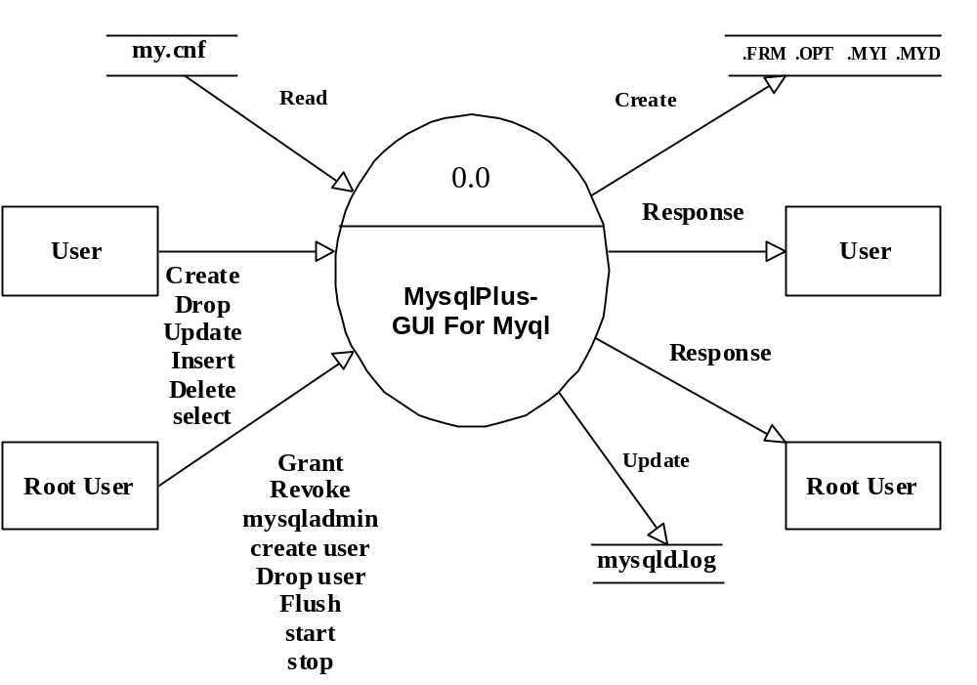

Amit Anil Bhalerao 11
MysqlPlus-GUI for Mysql

4.2 First Level DFD
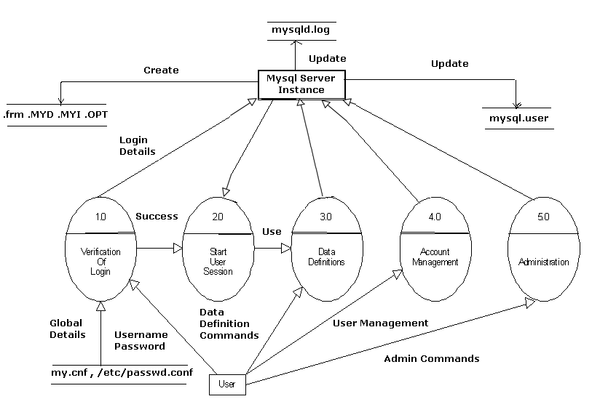

Amit Anil Bhalerao 12
MysqlPlus-GUI for Mysql

4.3 Use Case Diagram
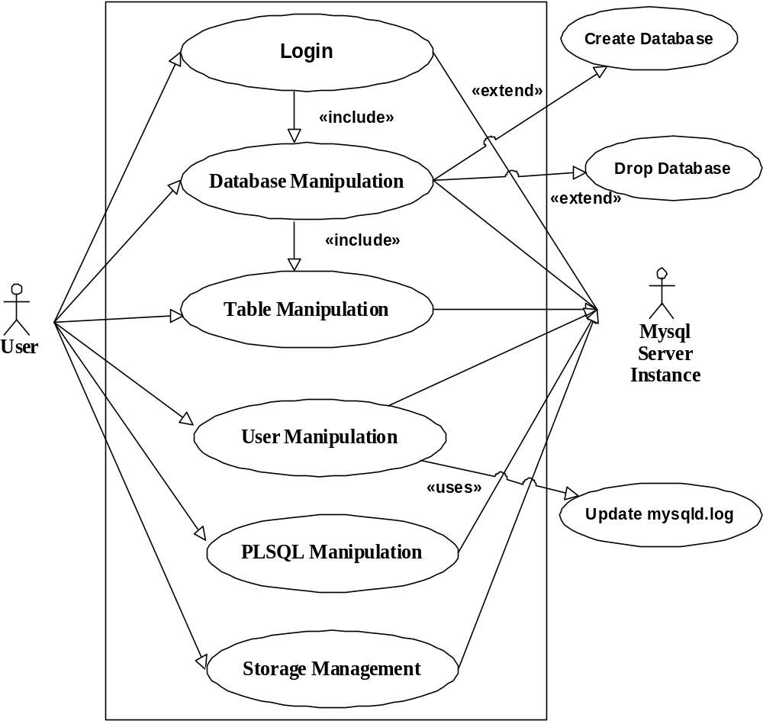

Amit Anil Bhalerao 13
MysqlPlus-GUI for Mysql

  - Sequence Diagram(Website)

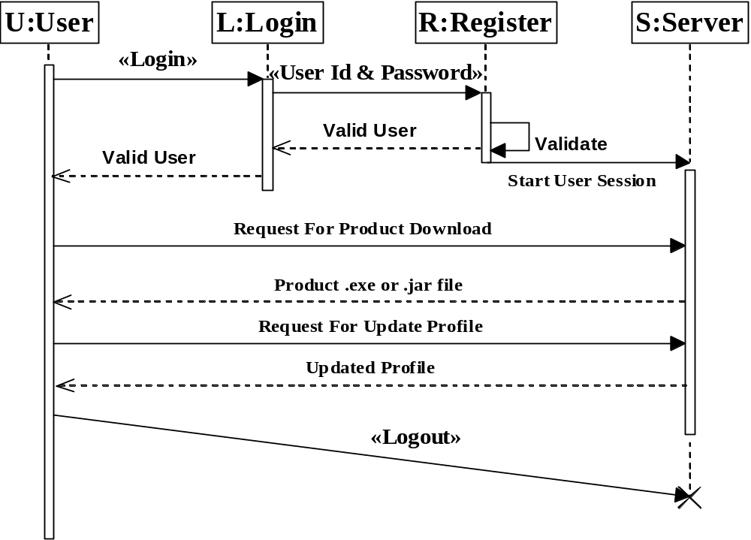

Amit Anil Bhalerao 14
MysqlPlus-GUI for Mysql

4.5 Class Diagram
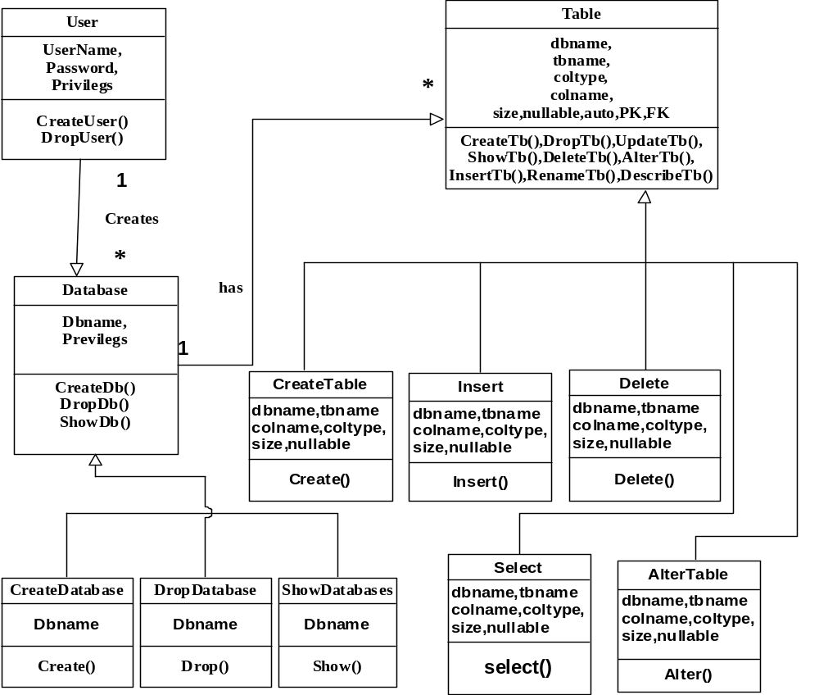

Amit Anil Bhalerao 15

5

MysqlPlus-GUI for Mysql

Program Specification & Coding system
In order know about how MySql works we have studied its working very briefly.We need at least mysql and mysql-server packages installed to set up MYSQL.
In order to interact with MySql we must first start it if it is not running. Various operating Systems follow different criteria to accomplish this activity.
Linux:-
- Starting MySql Service : [root@localhost ~]# service mysqld start
- Stopping MySql Service : [root@localhost ~]# service mysqld stop
- Restarting Mysql Service : [root@localhost ~]# service mysqld restart
Microsoft Windows:-
- Starting MySql Service : C:\> net start mysql
- Stopping MySql Service : C:\> net stop mysql
To know about the status of mysql we can use status command
mysql> status
C:\Program Files\MySQL\MySQL Server 5.0\bin\mysql.exe Ver 14.12 Distrib 5.0.37,
For Win32 (ia32)
Connection id : 11
Current database : -------------
Current user : root@localhost
SSL : Not in use
Using delimiter : --------------

Amit Anil Bhalerao 16
MysqlPlus-GUI for Mysql

Server version : 5.0.37-community-nt MySQL Community Edition (GPL)
Protocol version : 10
Connection : local host via TCP/IP
Server characterset : latin1
Db characterset : latin1
Client characterset : latin1
Conn. characterset : latin1
TCP port : 3306
Uptime : 5 hours 10 min 43 sec
Threads : 1 Slow queries : 0 Flush tables: 1 Queries per second avg: 0.004
Questions: 66 Opens : 19 Open tables: 0

Amit Anil Bhalerao 17

6

MysqlPlus-GUI for Mysql

      - Login

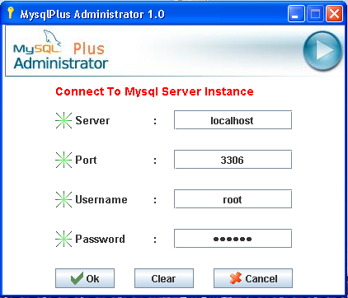

Amit Anil Bhalerao 18
MysqlPlus-GUI for Mysql

2) Main GUI

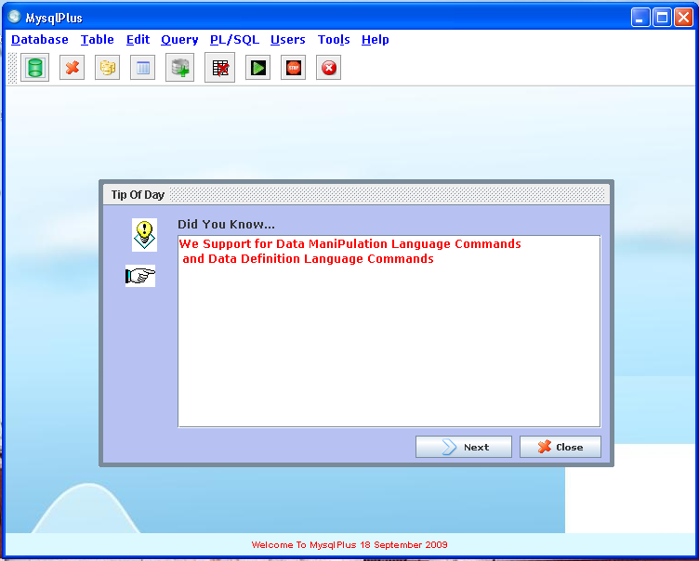

Amit Anil Bhalerao 19
MysqlPlus-GUI for Mysql

- Create Database

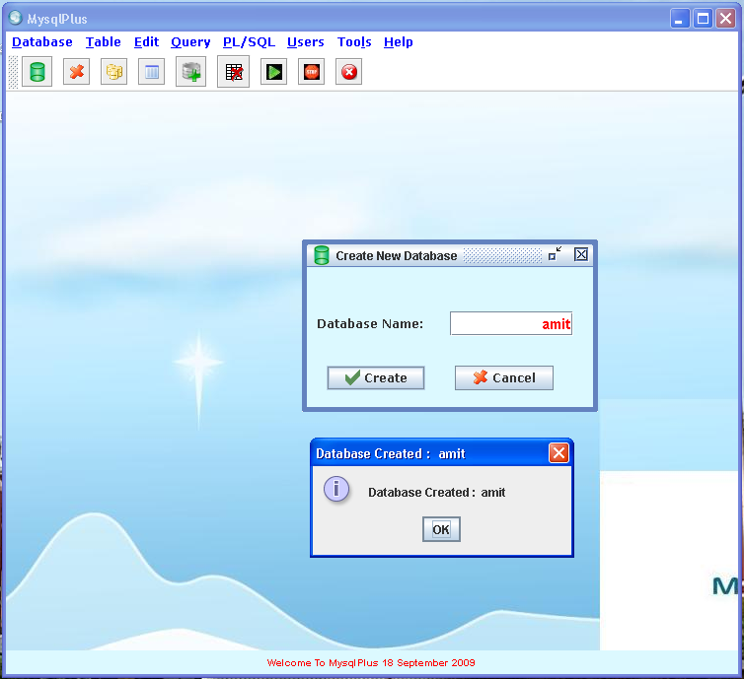

Amit Anil Bhalerao 20
MysqlPlus-GUI for Mysql

- Drop Database

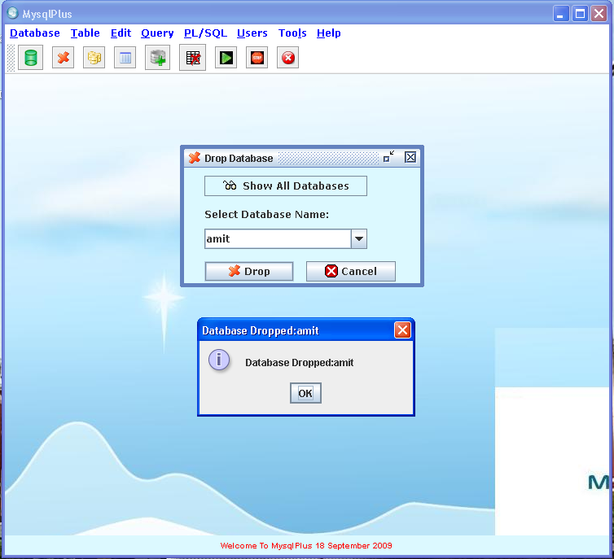

Amit Anil Bhalerao 21
MysqlPlus-GUI for Mysql

- Show Databases

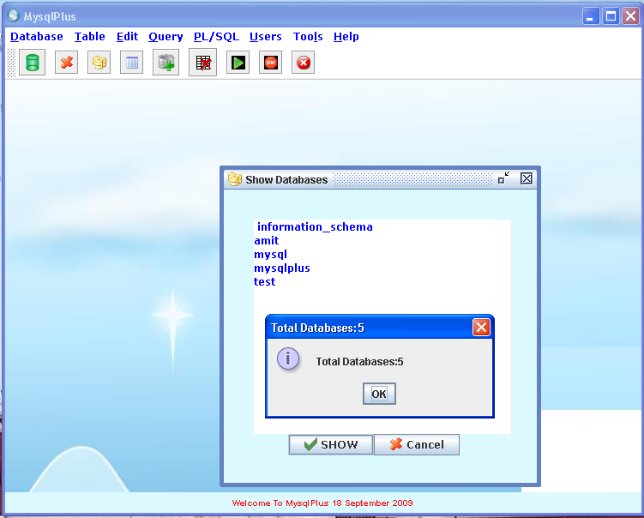

Amit Anil Bhalerao 22
MysqlPlus-GUI for Mysql

- Create Table

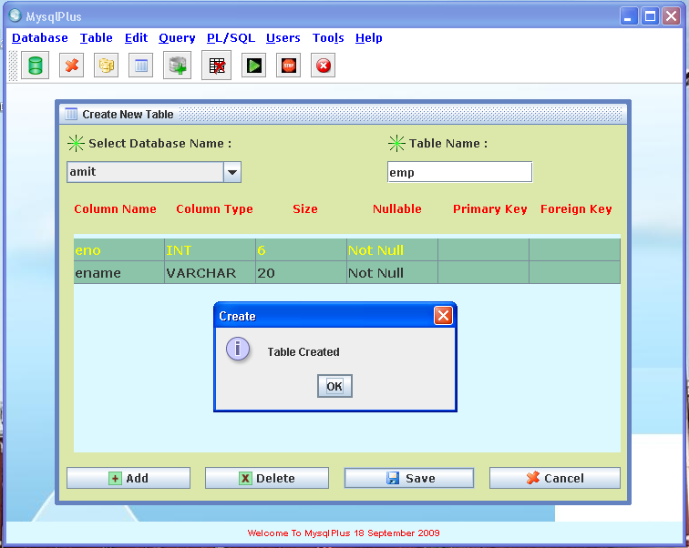

Amit Anil Bhalerao 23
MysqlPlus-GUI for Mysql

- Describe Table

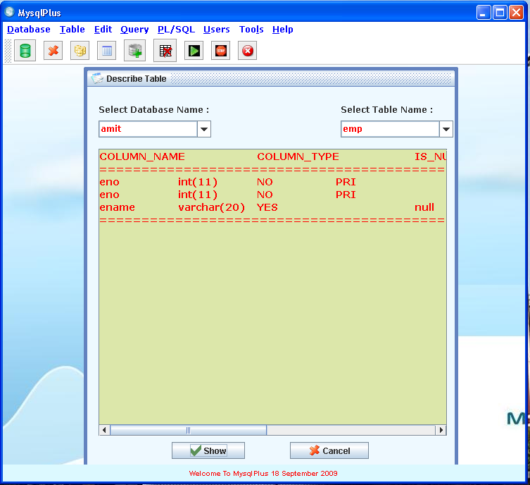

Amit Anil Bhalerao 24
MysqlPlus-GUI for Mysql

- Show Tables

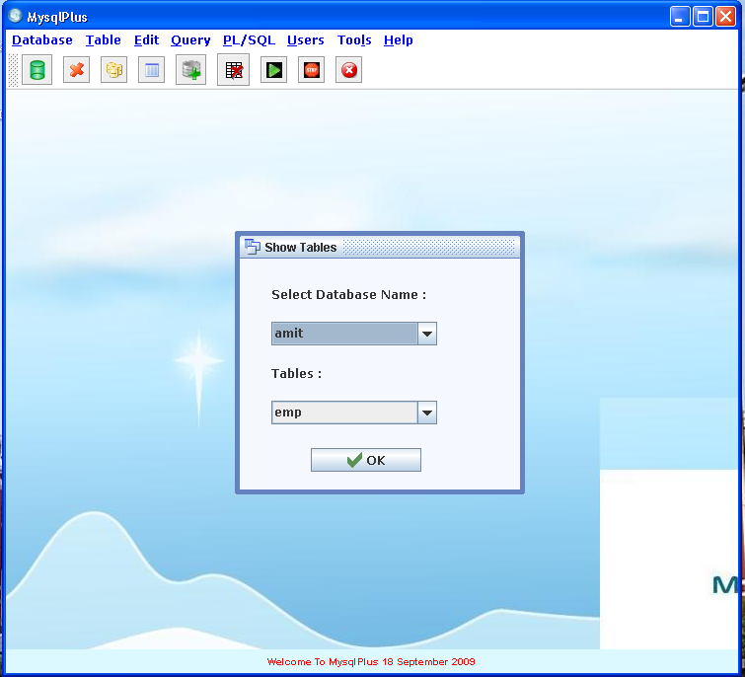

Amit Anil Bhalerao 25
MysqlPlus-GUI for Mysql

- Insert Data Into Table

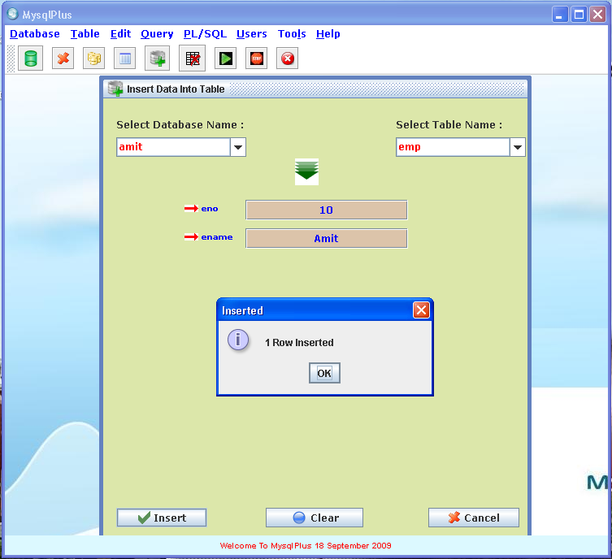

Amit Anil Bhalerao 26
MysqlPlus-GUI for Mysql

- Show Table Data

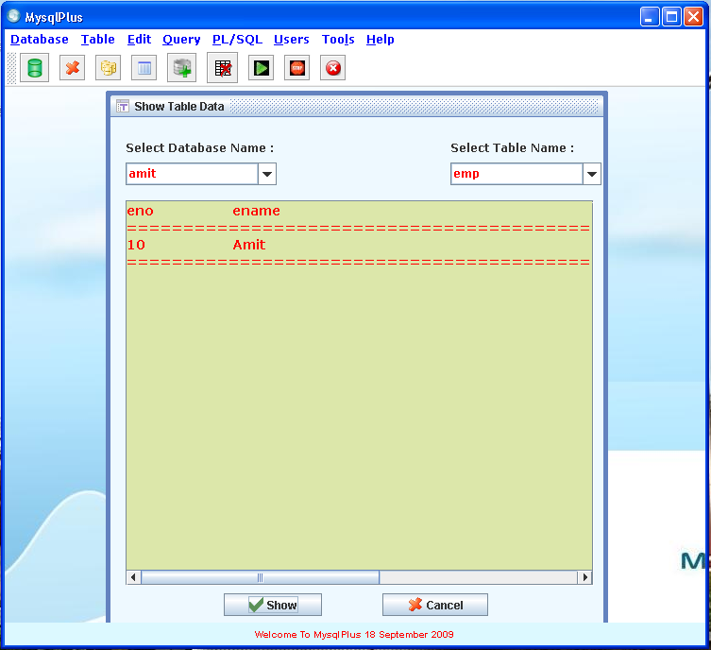

Amit Anil Bhalerao 27
MysqlPlus-GUI for Mysql

- Alter Table

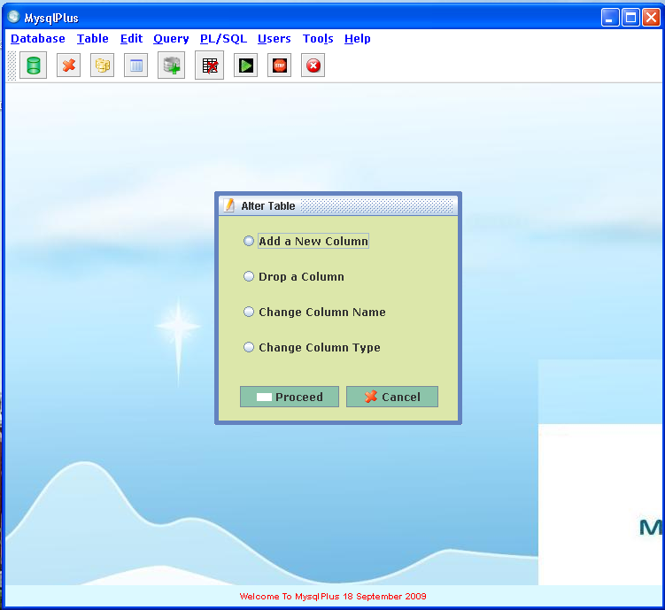

Amit Anil Bhalerao 28
MysqlPlus-GUI for Mysql

- Alter Table – Add New Column

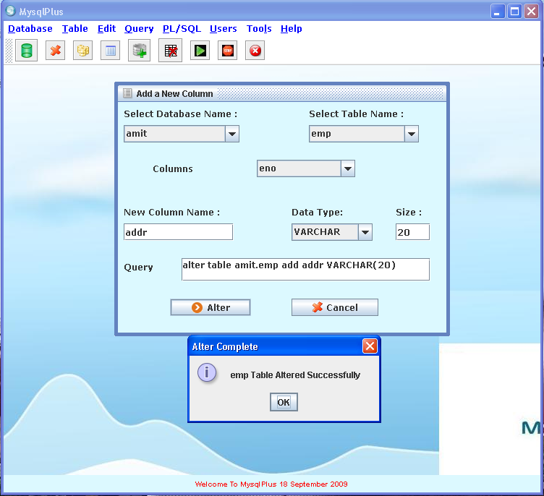

Amit Anil Bhalerao 29
MysqlPlus-GUI for Mysql

- Alter Table : Change Column Name

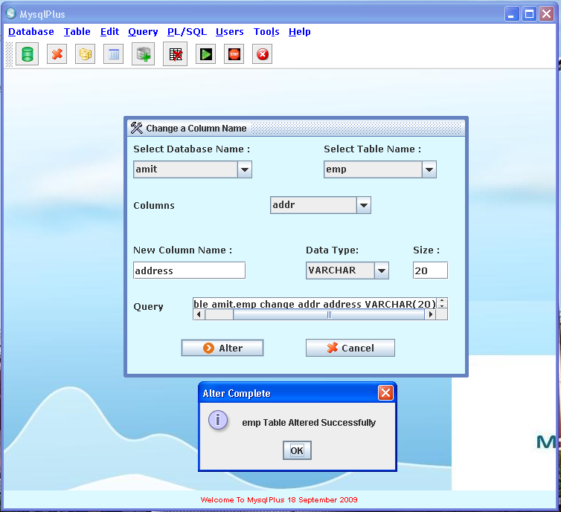

Amit Anil Bhalerao 30
MysqlPlus-GUI for Mysql

- Alter Table : Change Column Type

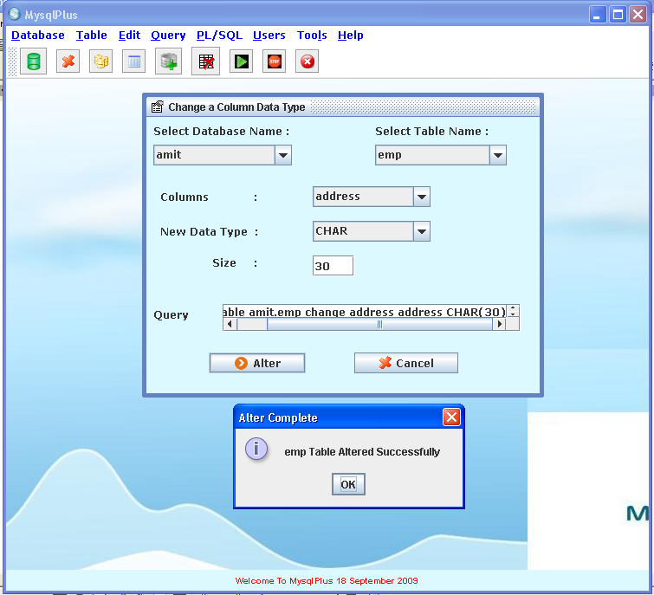

Amit Anil Bhalerao 31
MysqlPlus-GUI for Mysql

- Alter Table : Drop Column

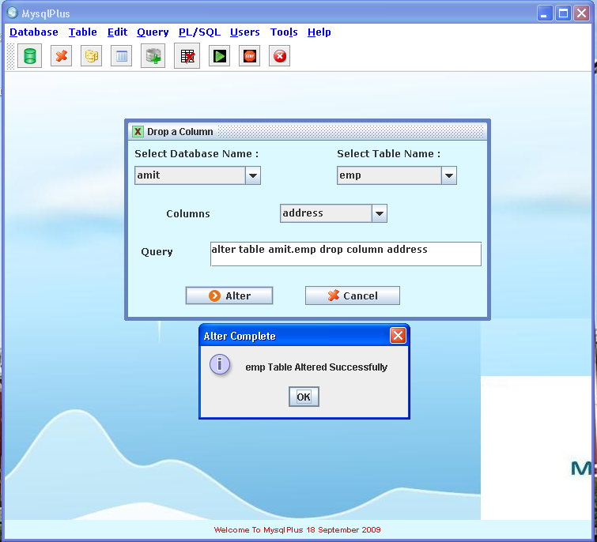

Amit Anil Bhalerao 32
MysqlPlus-GUI for Mysql

- Rename Table
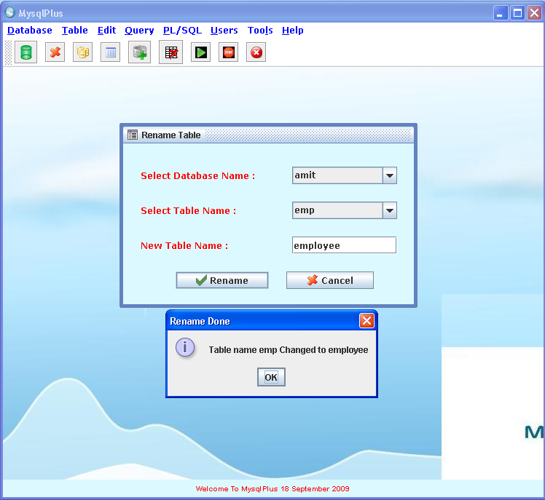

Amit Anil Bhalerao 33
MysqlPlus-GUI for Mysql

17) Delete Data from Table

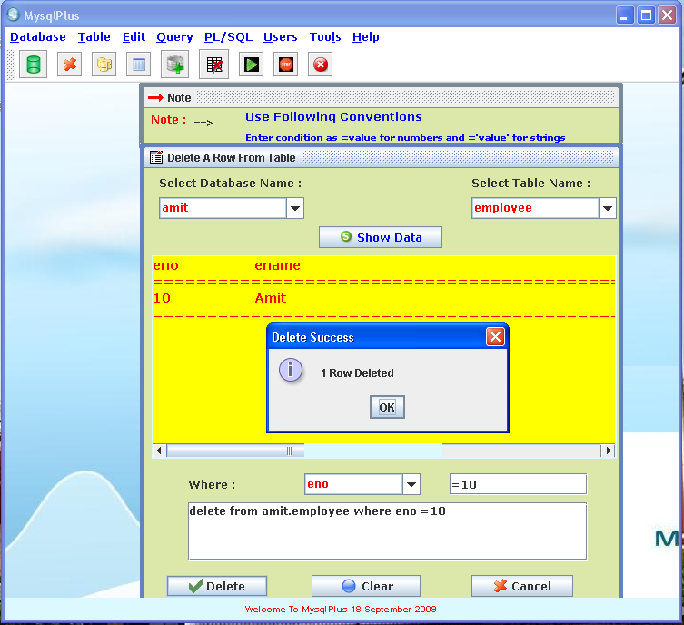

Amit Anil Bhalerao 34
MysqlPlus-GUI for Mysql

18) Drop Table

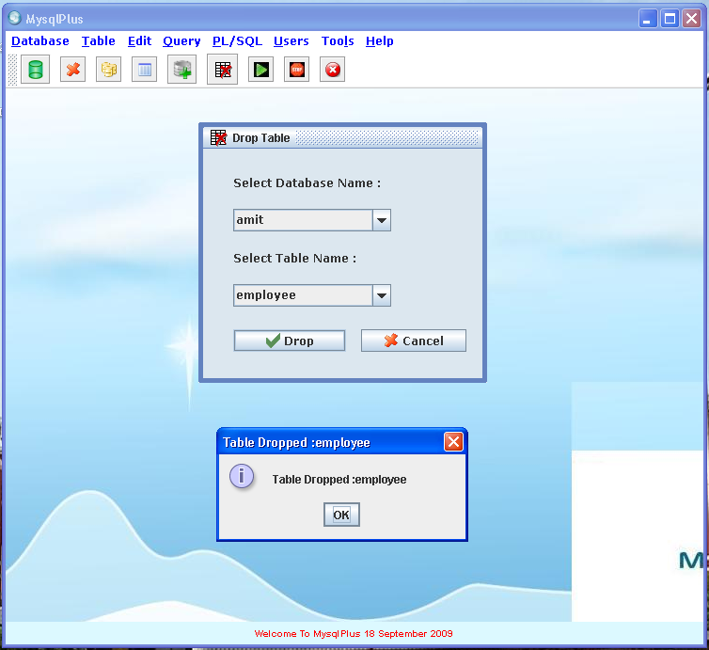

Amit Anil Bhalerao 35
MysqlPlus-GUI for Mysql

- Custom Query Window

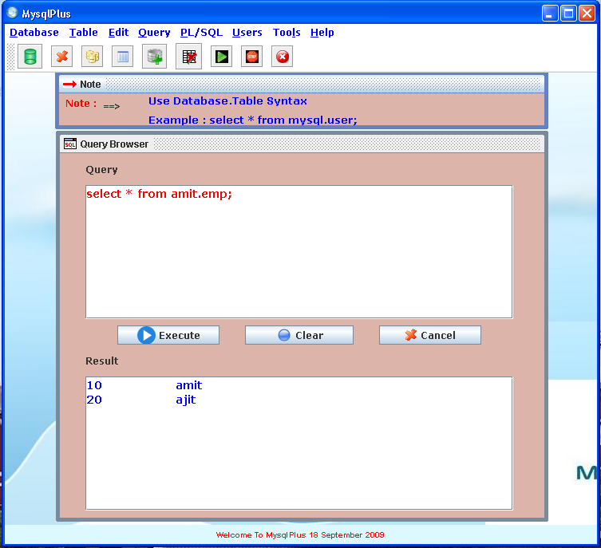

Amit Anil Bhalerao 36
MysqlPlus-GUI for Mysql

- Load Query From File

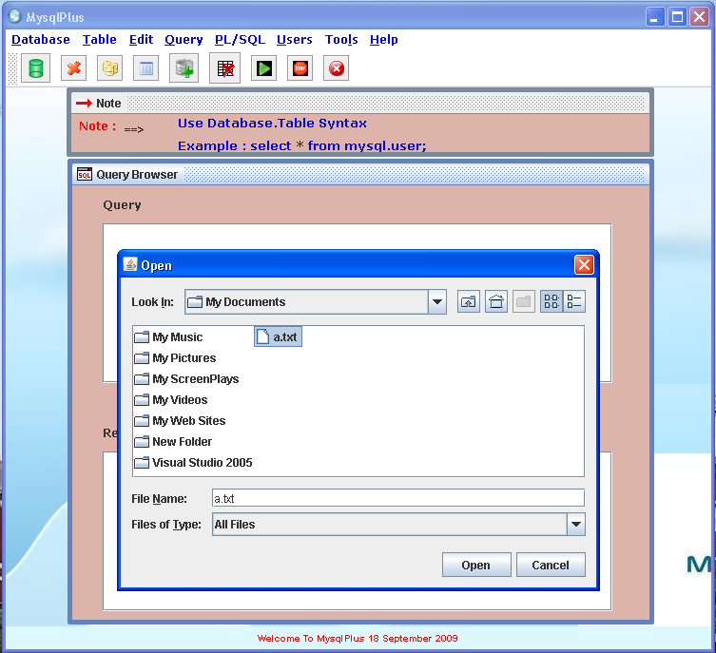

Amit Anil Bhalerao 37
MysqlPlus-GUI for Mysql

21) Save Query to File
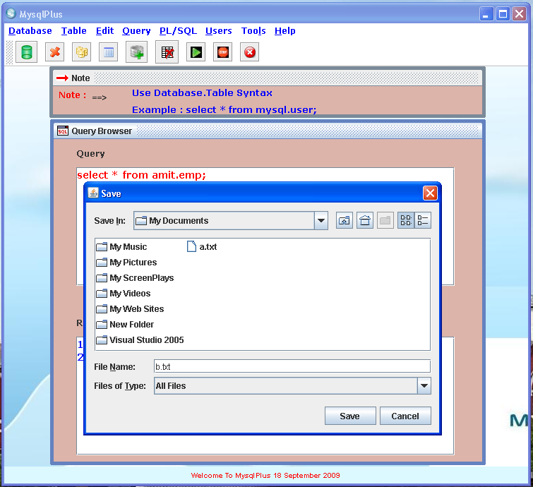

Amit Anil Bhalerao 38
MysqlPlus-GUI for Mysql

- Views

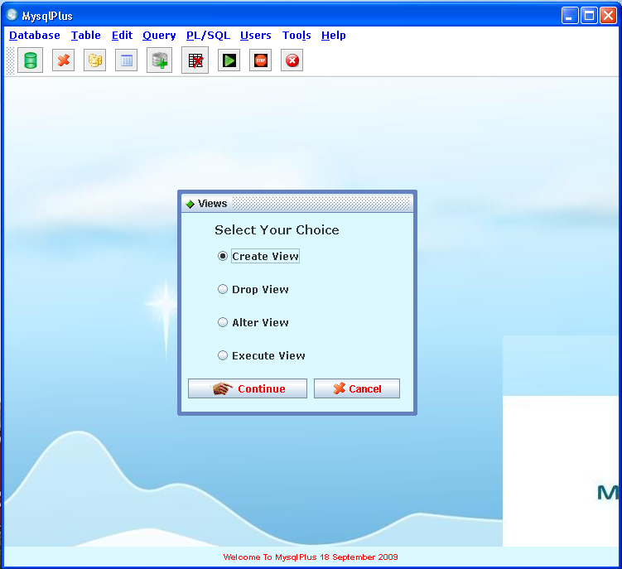

Amit Anil Bhalerao 39
MysqlPlus-GUI for Mysql

- Creating View

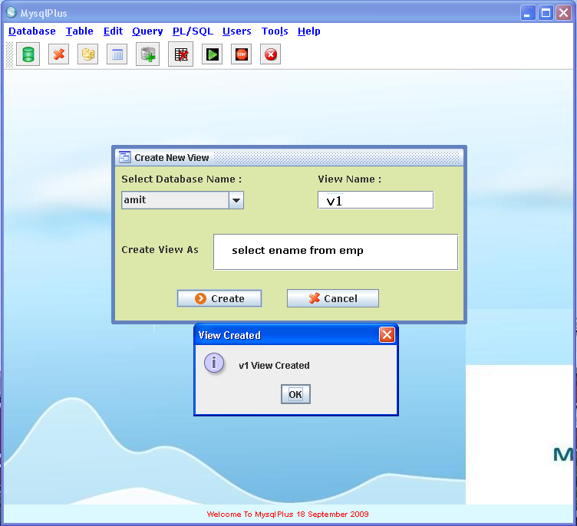

Amit Anil Bhalerao 40

MysqlPlus-GUI for Mysql

- Executing A View

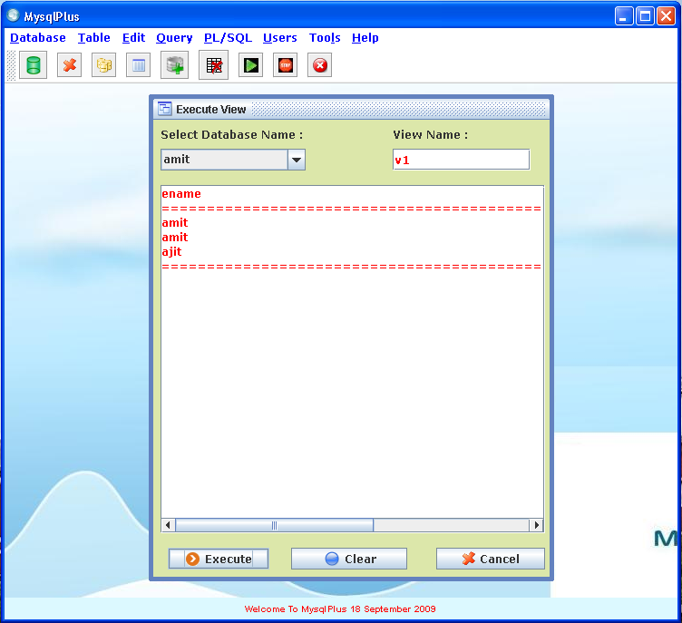

Amit Anil Bhalerao 41
MysqlPlus-GUI for Mysql

- Altering View

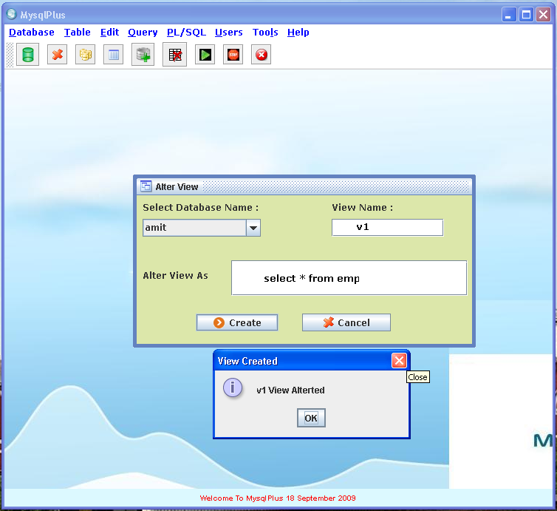

Amit Anil Bhalerao 42
MysqlPlus-GUI for Mysql

- Dropping View

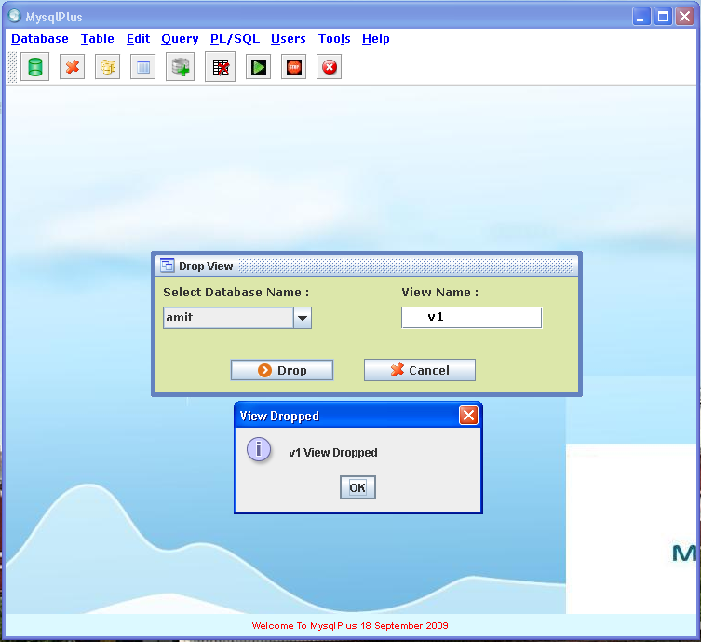

Amit Anil Bhalerao 43
MysqlPlus-GUI for Mysql

- Triggers

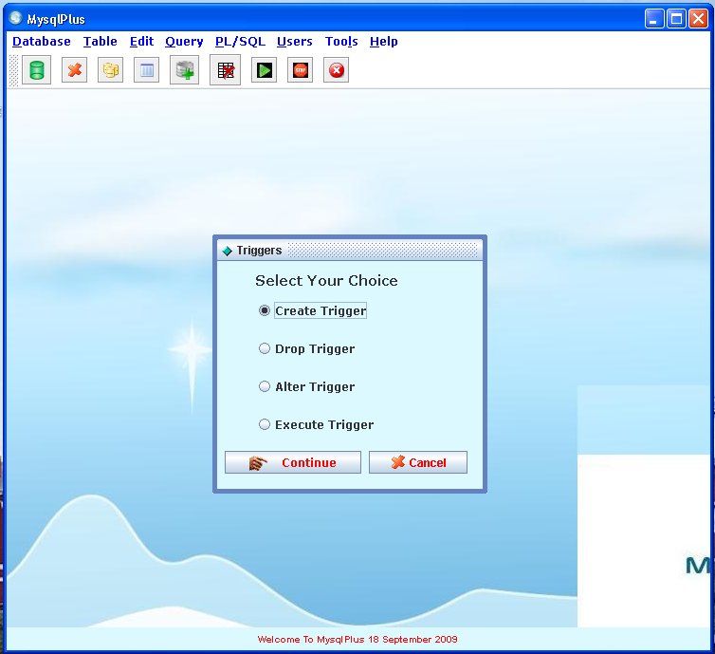

Amit Anil Bhalerao 44
MysqlPlus-GUI for Mysql

- Creating A Trigger

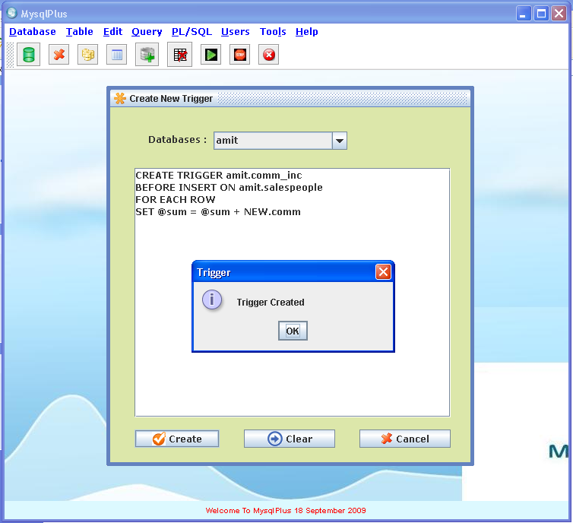

Amit Anil Bhalerao 45
MysqlPlus-GUI for Mysql

29) Dropping Trigger
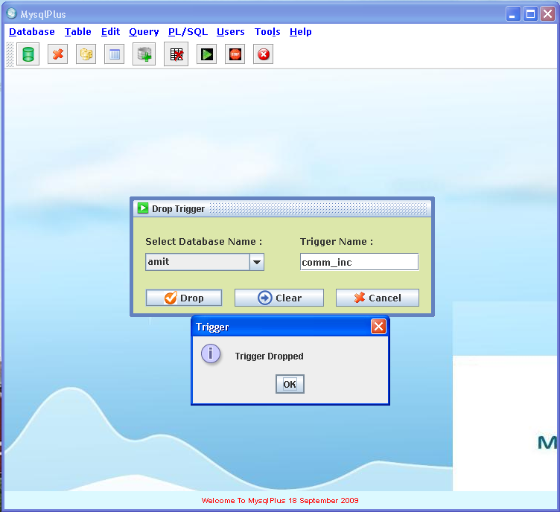

Amit Anil Bhalerao 46
MysqlPlus-GUI for Mysql

- MySql Engines
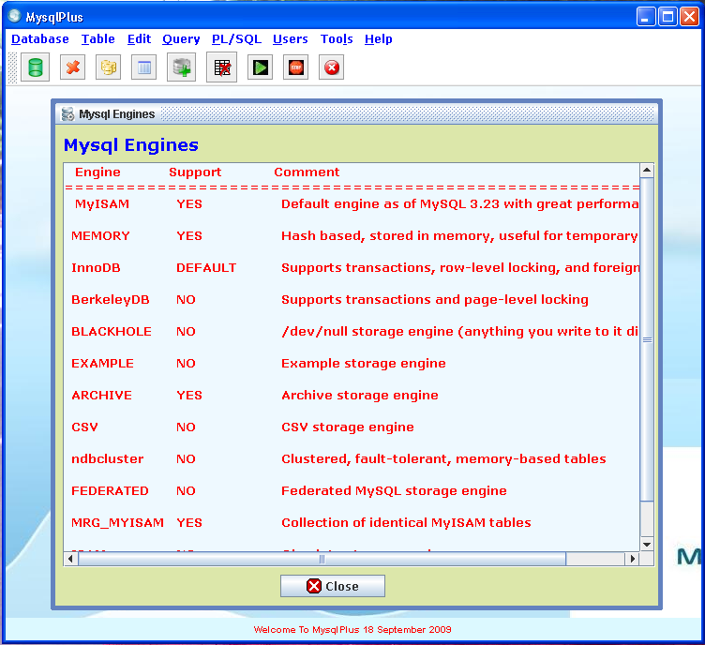

Amit Anil Bhalerao 47
MysqlPlus-GUI for Mysql

- Object Browser

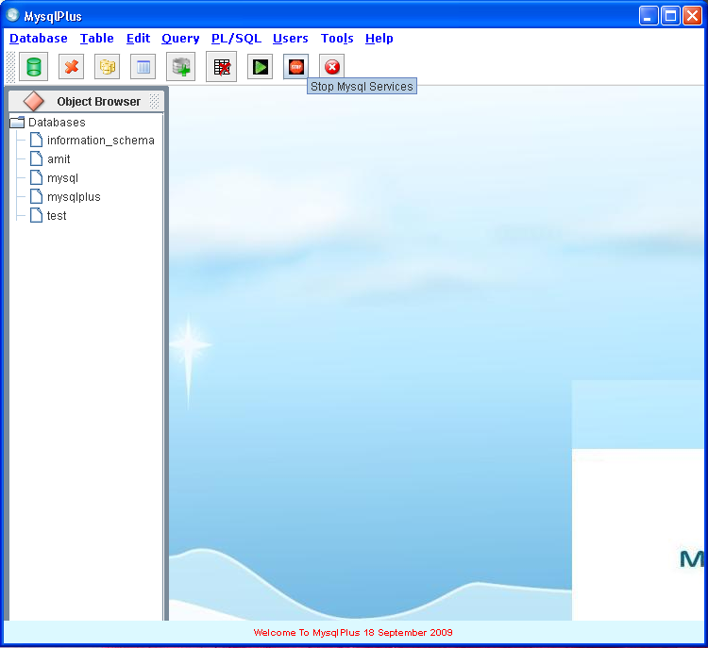

Amit Anil Bhalerao 48
MysqlPlus-GUI for Mysql

31) MysqlPlus Help
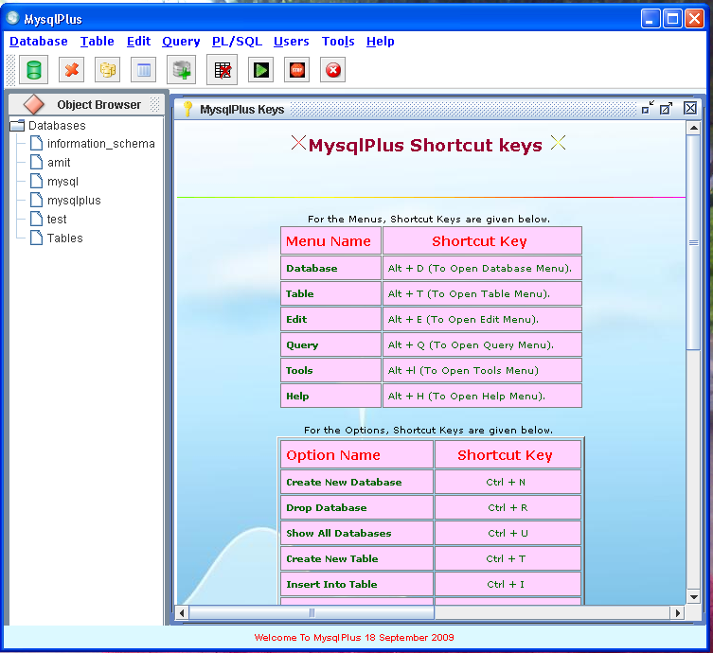

Amit Anil Bhalerao 49
MysqlPlus-GUI for Mysql

32) Tip Of Day
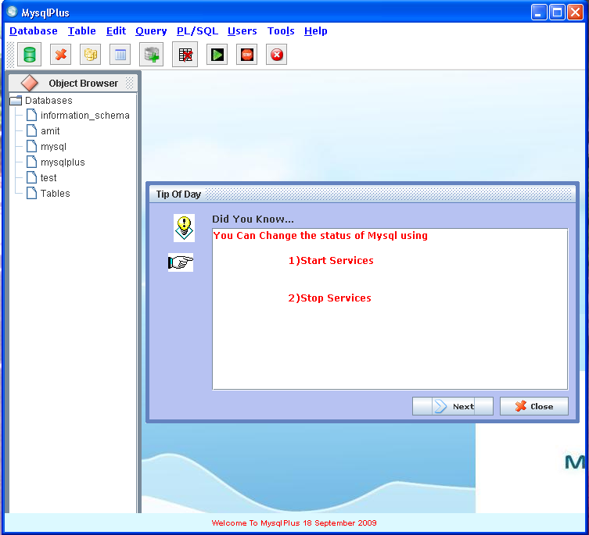

Amit Anil Bhalerao 50
MysqlPlus-GUI for Mysql

33) License
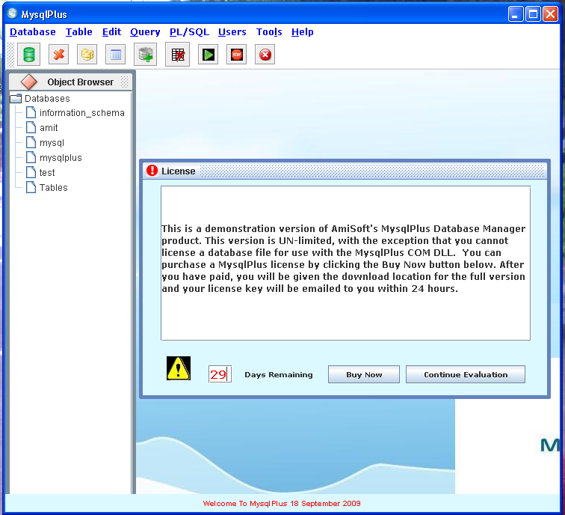

Amit Anil Bhalerao 51

7

MysqlPlus-GUI for Mysql

Proposed Enhancements
Following are the proposed enhancements

  - Importing and exporting databases to and from System.

  - MySql Database recovery tool can be added.

  - Performance of Mysql using Graphical charts can be shown.

Amit Anil Bhalerao 52

8

MysqlPlus-GUI for Mysql

8.1 Tangible & Intangible benefits

- Users are able to create and manipulate databases very easily and quickly.

- Easy to use.

- Good Graphical User Interface

- Quick design,insertion,dropping of tables

- Easy to import the queries from saved file.

- Easy to export the queries to a file

- Portable

Amit Anil Bhalerao 53

MysqlPlus-GUI for Mysql

8.2 Limitations of the system
→ System needs to have the latest version of JDK to be installed on System.

  - System needs to have the MySql installed.

  - In order to install MysqlPlus on Linux environment the CLASSPATH of system must
be configured properly

Amit Anil Bhalerao 54
MysqlPlus-GUI for Mysql

  - Conclusion
This system provides an easy access to following
  - Creation and dropping of databases and tables
  - Manipulation on tables
  - Changing the data types and sizes of column names
  - Writing Custom Queries
  - Loading and saving queries to and from files
  - Managing users
  - Providing help
  - Performing edit operations

Amit Anil Bhalerao 55

9

MysqlPlus-GUI for Mysql

References –
- www.java.sun.com
- www.java2s.com
- www.mysql.com
- www.google.com
- Java Complete Reference – Herbert Schidlet
- Managing and using MySQL-Tim King

Amit Anil Bhalerao 56

